Progress Report I – Webpage Sprint

University of Alberta – CMPUT 401 – Winter 2013 – BioMembranes

# Sprint Backlog

Items which were not completed and deferred to the next sprint are shown *italicized and in red.*

|  |  |  |  |
| --- | --- | --- | --- |
| **Task** | **Story Points** | **Assigned To** | **Completed By** |
| Web – Django Models | 3 | Cameron | Cameron |
| *Web – Upload Form* | 1 | Richard |  |
| Web – Queue and Run Task | 3 | Cameron | Cameron |
| *Web – Display Results* | 3 | James |  |
| Web – ICS Program View | 3 | James | James |
| Backend – Refactor Initial Prototype / Proof of Concept | 0.5 | Omar | Omar |
| Backend – Add Unit Tests | 3 | Omar, Glen | Omar, Glen |
| Backend – Add Image Formats | 3 | Omar, Glen | Omar, Glen |
| Backend – Add support for channel separated images | 0.5 | Cameron | Cameron |
| *Local GUI – Load Images* | 1 | Richard |  |
| Local GUI – Basic GUI in place | 3 | Nick | Nick |
| *Local GUI – Call the backend* | 1 | Nick |  |
| *Local GUI – Display results* | 1 | Richard |  |
| *Integration Tests Part 1* | 3 | Glen |  |
| Requirements Technical Review – Findings Report | 5 | Everyone | Everyone |
| Requirements Technical Review – 25 Minute Meetings | 1 | Everyone | Everyone |
| Update Documents | 1 | Nick | Nick |

It was expected that this sprint would contain **33** story points, but it actually contained **36** due to items deferred from the Webpage sprint. This means it is **1.1 times** larger than expected.

Of the **36** story points in this sprint, **26** were completed and **10** were not completed. This means that **28%** of the story points were deferred to the Batch sprint.

So far, **55.5** of the **170.5** planned story points are complete, meaning the project is about **32.6**% finished.

# Burn-Down Chart

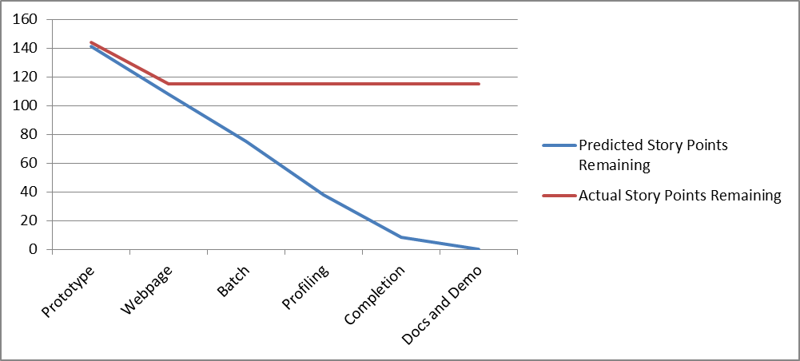

# Hours Breakdown (Webpage Sprint)

|  |  |
| --- | --- |
| **Team Member** | **Hours Breakdown** |
| Glen | 3 (EPL Doc)  + 4 (Command Line Interface updates)  + 2 (Acceptance Tests)  + 0.5 (Integration Tests)  + 1.5 (Expanding Image Formats)  + 0 (Unit tests - didn't get done)  Total: 11 hours |
| Nick | 5 (Local GUI Storyboard)  + 5 (EPL Requirements Technical Review)  + 1 (Creating basic local GUI)  + 1 (Progress Report)  Total: 12 hours |
| Omar | 10 (Batch Work) + 4 (Misc. Backend Tasks)  Total: 14 hours |
| Richard | 1 (Local GUI Tasks)  Total: 1 hour |
| Cameron | 3 (Django) + 2 (Celery)  + 1 (Image Reader)  Total: 6 hours |
| James | 8 (Web UI)  Total: 8 hours |

**Total Hours Spent: 52**

**26** story points were completed in **52** hours, indicating that each story point should take 2 hours to complete for the duration of this project.

# Contributions per Member

|  |  |  |
| --- | --- | --- |
| Member | Expected Points | Actual Points |
| Cameron | 7.5 | 7.5 |
| Glen | 7 | 4 |
| Nick | 6 | 5 |
| Richard | 4 | 1 |
| James | 4 | 4 |
| Omar | 4.5 | 4.5 |

# Hours per Member